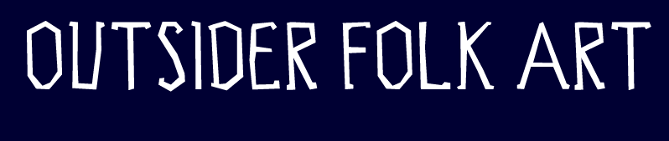

Contact: Emily Christensen
Outsider Folk Art Gallery
Suite 504
201 Washington St.
Reading, PA 19601
Tel: 610-939-1737
Fax: 610-939-1738
Hours: Wednesday- Friday 10 am- 6pm, Saturday-Sunday 11 am- 5 pm and by appointment
www.outsiderfolkart.com george@outsiderfolkart.com

May 28, 2008

FOR IMMEDIATE RELEASE

Outsider Folk Art Gallery: “Internal Guidance Systems” July 13th- August 24, 2008

We are proud to host “Internal Guidance Systems” a traveling exhibition featuring a selection of international artists who represent the vanguard of a new modern movement in visionary art. Curated by artist Anne Grgich (Seattle, WA) and scholar Colin Rhodes, the show presents a rare opportunity to view this select grouping of alternative art, and should not be missed. Please join us for an opening reception Sunday, July 13th 3-6 p.m., with an artists’ talk at 4 p.m. Anne Grgich will teach a workshop at the GoggleWorks Saturday, July 19, please inquire for details.

The Outsider Folk Art Gallery, located inside of the GoggleWorks Center for the Arts, is owned by local collectors and dealers George and Sue Viener who have been collecting self-taught art for over 30 years. Art displayed from the Vieners’ collection is available for purchase. The gallery’s primary function is to expose and educate the public about outsider and self-taught art.

XXX

