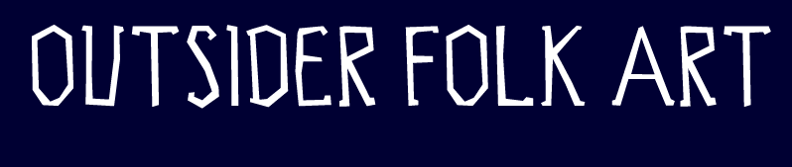

Contact: Emily Christensen
Outsider Folk Art Gallery
Suite 504
201 Washington St.
Reading, PA 19601
Tel: 610-939-1737
Fax: 610-939-1738
Hours: Tuesday- Saturday 11 am- 6 pm and by appointment
www.outsiderfolkart.com emily@outsiderfolkart.com

March 17, 2009

FOR IMMEDIATE RELEASE

“ECOLOGICALLY CORRECT: THE PHILADELPHIA DUMPSTER DIVERS”
APRIL 2 – JUNE 14, 2009

“PHILADELPHIA DUMPSTER DIVERS”IS A COLLECTIVE OF FOUND OBJECT ARTISTS THAT SUPPORT EACH OTHER IN CREATING ART FOR THE CONSCIOUS, CONTEMPORARY LIFE.

OPENING RECEPTION THURSDAY APRIL 2, 5-8 PM

ARTIST SYMPOSIUM AND ARTISTS RECEPTION “SECOND SUNDAY” MAY 10, 2009: SYMPOSIUM 12 – 2 PM IN GOGGLEWORKS FILM THEATRE, FOLLOWED BY RECEPTION IN GALLERY 2-5 PM.

The Philadelphia Dumpster Divers use found objects to make art. Beyond that, their similarities end. In the loosely bound artist collective there are BFAs and MFAs, career artists, sculptors, painters, photographers, school teachers, retirees, stay-at-home parents, all with unique visions for their work.
The real environmental impact of reused materials is “Ecologically Correct,” but it is through these diverse visions that the Dumpster Divers make their largest impact. Transformation of wastes of society to create meaning and beauty is achieved through the eyes of these artists.
Formed around 1992, the original members have deep roots in the Philadelphia arts community and have made invaluable contributions to its cultural flavor with their singular artistic achievements. Over seventeen years, the group has welcomed new generations who feed off its generous cooperative spirit as they pursue their own individual projects.
The Outsider Folk Art Gallery has spent the last year meeting the individual Philadelphia Dumpster Divers in their studios and viewing their artwork, and learning about the collective. “Ecologically Correct: The Philadelphia Dumpster Divers” is a result of this project.
The Dumpster Diver Symposium, 12-2 PM May 10, 2009, in the GoggleWorks’ Theatre, is an opportunity for the public to hear about the visions and techniques of the artists.
Participating Artists Include:
Isaiah Zagar
Leo Sewell
Harry Anderson
Smokie Kittner
Neil Benson
Ellen Benson
Randall Cleaver
Len Davidson
Mark May
Randy Dalton
George Bilyk
Valerie Black
Charmaine Caire
Alden Cole
Carol Cole
Bruce Gast
Linda Lou Horn
Hugo Hsu
John Jonik
Ann Keech
John Lindsay
Kathryn Pannepacker
Eva Preston
Ellen Sall
Joel Spivak
Toni Nash
Burnell Yow!
Betsy Alexander
Leslie Matthews
David Gerbstadt

The Outsider Folk Art Gallery, located inside of the GoggleWorks Center for the Arts, is owned by local collectors and dealers George and Sue Viener who have been collecting self-taught art for over 30 years. Art displayed from the Vieners’ collection is available for purchase. The gallery’s primary function is to present outsider and contemporary self-taught art.

XXX

